What’s the best way to connect one?
If a buffer tank is to be used, then the way it is connected is important. Traditionally they have tended to be connected ‘four pipe’ – flow in and out to the heat pump and flow in and out to the heating system. The down side of this arrangement is that the buffer becomes a permanent mixing point on the system, causing a permanent temperature step in the system. Although one or two specific exceptions do exist, this design should be avoided if possible as it will cause a permanent drop in system efficiency for no gain whatsoever.
A better arrangement (and the Kensa recommended way), is to connect a buffer tank using two connections only. This will prevent most of the flow passing through the buffer under most operating conditions, so minimising mixing, only under very light heating load will most of the flow enter the buffer – so the buffer only comes into play when actually necessary.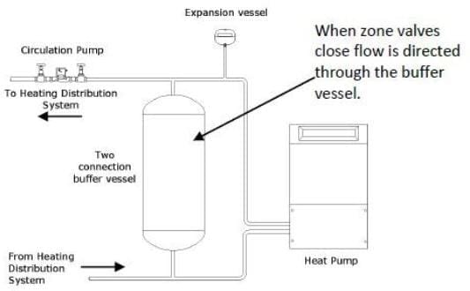
The buffer can be a good place to inject extra heat from other sources. By adding a coil within the buffer it can be used with excess solar heat, or heat from a backup boiler. By adding an electric immersion heater in the buffer, surplus PV power can be converted into useful heat using a PV controller. If using it with a backup boiler, then it is probably a good idea to connect the buffer ‘four pipe’ to get maximum heat transfer.

What about thermal stores?
The unwary could easily think that fitting a thermal store was a good substitute for both a buffer tank and a hot water cylinder, but when sourced from a heat pump this is not a good idea. Although the thermal store will usually function OK as a buffer, they don’t make good partners for heat pumps as all the space heating load then has to be served at DHW production temperatures – this will typically lead to very poor efficiency and result in high electricity bills.
A buffer tank can also be used for daily energy storage, although currently in the UK due to the lack of viable variable rate electricity tariffs these types of installations are rare. To serve this purpose the buffer will often have to be several thousand litres – finding a suitable location for this in a property without a basement can be a challenge. It also needs to be very well insulated to avoid the heat losses negating any running cost saving. The heat pump runs when the electricity is cheap,

