Subject: RE: 21/P/01334 - 11 Orchard Road - Site Photo Request [UNC]

Dear Eric,

I installed a noise meter at 9 Orchard Road for monitoring between 03 March 2022 – 16 March 2022. The noise meter was placed in one of the habitable room next to their carport.

- The following are the snap shot of the noise data for which noise recordings has been made by the complainant. The bedroom window is fixed and cannot be opened. Therefore the noise levels are mainly due to the internal disturbance or the fan noise. The orange highlighted area is where recordings have been made by the occupier of the ASHP noise. From the cyclical pattern and noise recordings, I can clearly see that the internal level is increased by 5dB when the ASHP is coming on (noise level in the range of 27dB with the fan on and dropping to around 20dB when it cuts out.

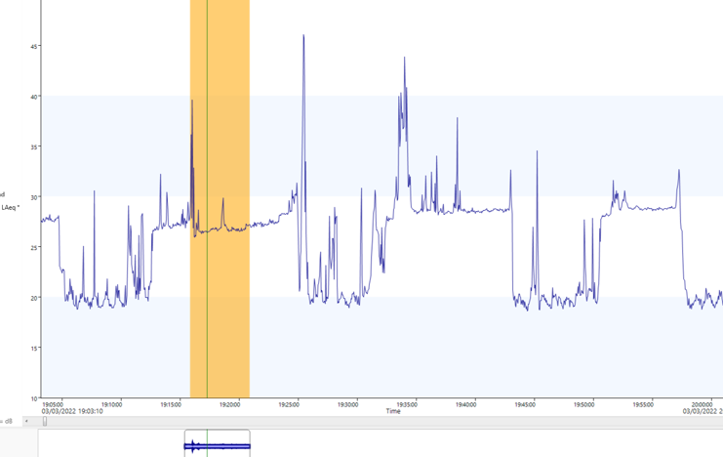

- In the night the noise levels stay in the range of 19dB as expected due to limited disturbance:

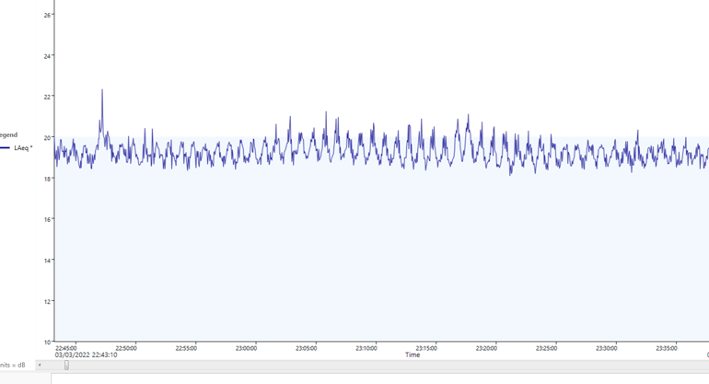

- Following is when the fan comes on. Again orange highlight is where noise recording is available
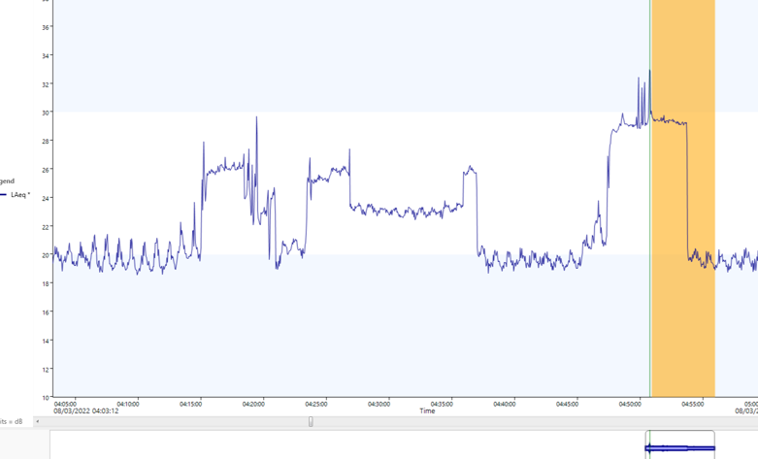

- Another snapshot to show the difference when the ASHP kicks in:
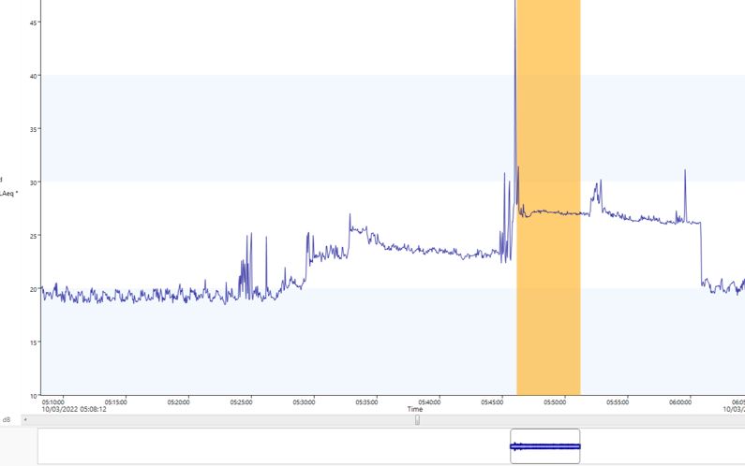

The noise from ASHP is resulting in 5dB increase in the noise level in this habitable room of the property. After applying a character correction of 5dB due to tonality and stop start nature, I would get a rating level of approximately 9-10dB above background which indicates significant adverse impact on the neighbouring property due to ASHP noise.

Please note that the noise monitoring in the residential garden has not been undertaken at this stage. However, I have sufficient evidence to indicate that the noise is amounting to statutory nuisance. Since the application require planning permission, if mitigation solution can be achieved via planning, service of abatement notice may not be necessary in public interest. However, service of abatement notice may have to be considered to avoid delays.

I hope this is of help. Please do not hesitate to contact should you have any further queries.

Regards

Compliance Officer – Environmental Protection
Environment and Regulatory Services

xxxxx

I’ve changed the subject and taken Planning off this thread

Thanks for the items below. I have numer of questions
- How do you know that the spikes in noise are directly attributable to the ASHP? It could quite possibly have been a truck driving past?
2. What time zone are the times metered at – i will try to correlate them to power usage of the AHSP which is when I could see it was running?
3. What is the defined threshold that is being broken for this to be considered a statutory nuisance? Is it a noise level issue, is it a length of noise issue, is it a time of day issue?
4. What mitigations can you suggest – e.g. what if I configured the ASHP to only run after 07:00 in the morning?
5. To my knowledge, the room next to the car port is not a bedroom. Why was the monitoring not done from a bedroom?
6. I assume there is a spreadsheet/data file that contains all the data over the 13 days of collection. Please can you supply that to me.

I will seek professional advice to get the right, and I will ensure that I am operating within the law, I want to solve it within clearly defined parameters. If I am to spend significant amounts of money to get through both the planning, and the noise compliant, then I want to esnure before I spend it that the probelsm will be solved. Hopes that mankes sense?

Many Thanks

Eric de Oude

Hi Eric,

Apologies, I could not respond to you yesterday.

1. How do you know that the spikes in noise are directly attributable to the ASHP? It could quite possibly have been a truck driving past?

I have only used the data, where noise recording is made by the complainant and I could hear the noise which was mainly related to the fan. Noise from truck driving past would gradually fade away and would not remain consistent, and you would see in the noise trace as well. I early morning around 5:00am there was a pattern of noise level increasing while other internal activities are expected to be minimal.

2. What time zone are the times metered at – i will try to correlate them to power usage of the AHSP which is when I could see it was running?
You can see the time and date in each graph that I have provided. The highlighted area is where the resident has made recordings.

3. What is the defined threshold that is being broken for this to be considered a statutory nuisance? Is it a noise level issue, is it a length of noise issue, is it a time of day issue?

It is noise level + frequency of occurrence+ length of the noise issue, all the factors. If noise monitoring has been undertaken, 3dB above background means doubling of sound energy, a change that human ears would perceive. If the noise is above 5dB then it is likely to amount to a statutory nuisance. Additional weightage is give if there is any special characteristic to the noise such as tonality or stop start as human ears would perceive it more.

4. What mitigations can you suggest – e.g. what if I configured the ASHP to only run after 07:00 in the morning?

Unfortunately, you will have to consult a specialist on the mitigation aspect. There could be a number of options from relocation/checking the installation is not creating structural noise/acoustic enclosure etc.

5. To my knowledge, the room next to the car port is not a bedroom. Why was the monitoring not done from a bedroom?

The room next to carport is a habitable room and it is personal choice of the people living there on how to use it. They may decide to use it as bedroom in future. I used that room because it would be minimally used and there would be less disturbance in the noise trace due to internal noise. Please note that the garden also forms part of the property and if they cannot enjoy their garden due to unreasonable fan noise, it is also likely to amount to statutory nuisance.

6. I assume there is a spreadsheet/data file that contains all the data over the 13 days of collection. Please can you supply that to me.
It is attached.

Best regards

Compliance Officer – Environmental Protection
Environment and Regulatory Services

Guildford Borough Council
Twitter

