**Homes risk energy rating downgrade if they install a heat pump**

Ministers to overhaul Energy Performance Certificate rules amid fears of hit to house prices

[By Tom Rees](https://www.telegraph.co.uk/authors/t/tk-to/tom-rees/) and [Tony Diver,](https://www.telegraph.co.uk/authors/t/tk-to/tony-diver/) Political Correspondent 6 February 2022 • 9:30pm

Energy scores for homes are to be overhauled by the Government, amid fears that under the current system installing a heat pump could cut the value of properties.

It comes after The Telegraph disclosed that [several Cabinet ministers were already concerned about the speed of the transition to net zero](https://www.telegraph.co.uk/politics/2022/02/03/ministers-urge-boris-johnson-rethink-net-zero-plans-cost-living/) and cost to households, amid record energy price increases and the biggest cost-of-living squeeze in a generation.

Energy Performance Certificates (EPC) grade a house from A to G based on efficiency, and the rating is increasingly tied to property prices.

Landlords are required to hit a minimum rating under upcoming rules and some mortgage providers take the certificates into account when lending.

But the way that the ratings are currently estimated means that replacing a traditional gas boiler with a heat pump can lower a home's energy efficiency rating.

The Government has held meetings with the industry about a possible rule change to rectify the issue, The Telegraph can disclose.

A Whitehall source said: "We are aware of this problem and it is being reviewed."

The Conservative MP Craig Mackinlay, the chairman of the Net Zero Scrutiny group, said: "Given that heat pumps can actually increase energy use, on which EPC certification is derived, they could push a property that might have been rated C under an old method into D.

"That could make it both unrentable and possibly even unsaleable, if some of the more nonsensical Net Zero measures that we hear about are realised."

EPCs are currently based on an estimate of what it costs to heat a home rather than the carbon emissions generated. Heat pumps - which transfer thermal energy into a property from the ground or air - produce less CO2 than burning gas, but are not necessarily recorded as being cheaper to run.

The Prime Minister has vowed to wean British households off natural gas as part of his pledge to hit net zero by 2050.

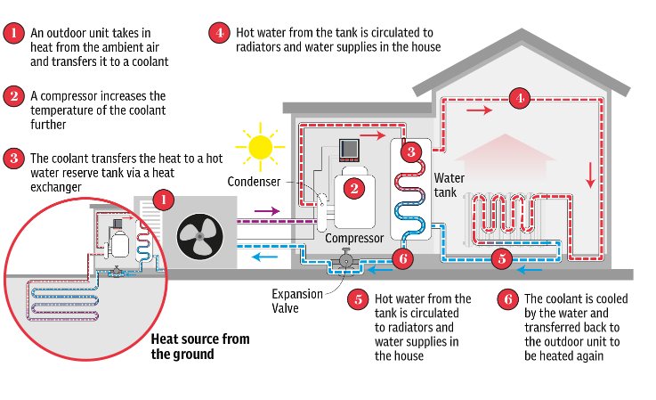

A heat pump can cost up to £20,000 and is currently the only mainstream alternative to a gas boiler. The graphic above shows how it works.

Ministers hope to eventually switch to a system where boilers can burn hydrogen, but the technology for this has never been used in housing at a meaningful scale.

Rishi Sunak, the Chancellor, and Kwasi Kwarteng, the Business Secretary, have made the case that the UK should continue to rely on domestic gas production as the country transitions to net zero, rather than relying solely on renewable energy sources.

The EPC system was drawn up in 2007 as a way of nudging property owners into making their houses more efficient. It has become increasingly important over time, with lenders such as Natwest now offering so-called green mortgages with cheaper rates for properties graded A or B.

The Telegraph revealed last month that Lloyds, the UK’s biggest mortgage lender, is [looking at including EPC ratings in its home loan affordability tests](https://www.telegraph.co.uk/business/2022/01/23/lloyds-mulls-looser-mortgage-tests-well-insulated-homes/).

The Government has also proposed a voluntary target for lenders to improve the average rating of homes on their books to at least band C by 2030, and landlords have been told they must achieve an EPC rating of at least C on new tenancies from 2025.

Improving a property's energy rating from G to A can increase its value by as much as 14 per cent, according to research from Moneysupermarket.

Martyn Reed, the managing director at Elmhurst Energy, said the ratings were “already impacting the price of poorly performing homes” as “you’re basically excluding landlords from buying your property because they won’t be able to rent that property”.

He added: “The methodology, called SAP, which drives [the EPC] calculation, hasn't been updated since 2012 so a lot of the pricing information in there is very old.

“Even though a heat pump is four times [more] efficient, the electricity was more than four times the cost of the gas… which created an inconvenient truth that government policy was moving from gas boilers to heat pumps, [whereas] the EPC, which is the measure of energy efficiency, suggested actually that the property was less efficient.”

Only a tenth of the 22million dwellings in England and Wales get the top A and B grades with around 60 per cent having an EPC rating of D and below.

The Government is set to unveil an update on EPCs in 2022 after launching an action plan.

An industry source said: “There are meetings going on almost monthly with the Business Department. They understand the issues, they've got plans in place but it's quite complicated. They are putting lots of resources into getting it fixed and getting it fixed quickly… It just should have been done five years ago.”

Nicholas Mendes, the mortgage technical manager at John Charcol, said the current EPC system was “not fit for purpose” as the green ratings became crucial in lenders’ mortgage calculations.

He said: “Having an A, B, or C EPC rating will no longer be a unique selling point, but the expectation. Whether you’re purchasing or remortgaging, be prepared, as we could see the best rates be for green mortgages in the future.”

A spokesman for the Business Department said: “Energy Performance Certificates provide useful guidance for consumers and businesses outlining how energy efficient buildings are in a simple and comparable manner.

“We are already looking at ways the system can be improved through our EPC Action Plan to ensure they are as accurate and effective as possible.”